- Forensic Analysis of Video Files Using Metadata

MP4 video file’s metadata to solve multiple video forensics problems including brand attribution video editing tool identification social network attribution and manipulation detection

https://openaccess.thecvf.com/content/CVPR2021W/WMF/html/Xiang_Forensic_Analysis_of_Video_Files_Using_Metadata_CVPRW_2021_paper.html

chrome-extension://efaidnbmnnnibpcajpcglclefindmkaj/https://openaccess.thecvf.com/content/CVPR2021W/WMF/papers/Xiang_Forensic_Analysis_of_Video_Files_Using_Metadata_CVPRW_2021_paper.pdf

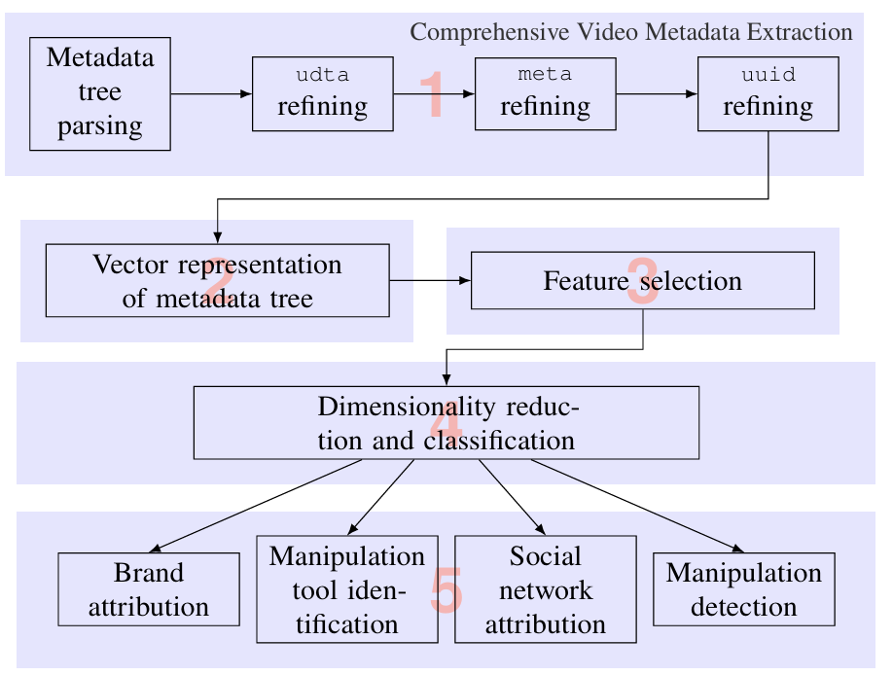

- Metadata in Video Databases

https://dl.acm.org/doi/epdf/10.1145/190627.190638

- An Ensemble Framework for Video Authentication Using File Signatures, Metadata Analysis, and Deep Learning-Based Quantization

https://ieeexplore.ieee.org/abstract/document/11292040

Datasets
- https://github.com/ondyari/FaceForensics/tree/master/dataset
- https://www.kaggle.com/datasets/kanzeus/realai-video-dataset

